**Assignment 4 Team 11**

**Dataset creation Steps :**

1. **We take the raw data folder and execute the create_train_test_folder.m file with the reference of the downloaded raw data folder. This execution created two folders ‘train’ and ‘test’ which contains the csv files for those 10 actions from DM01-DM37.**
2. **As we did for Assignment 3:**

* we generated a folder called ‘processed_data’ which had 10 .csv files for each action. Each of these files was a vertical concatenation of data for each action done 20 times. This was done by running the file called ‘processData.m’.
* We generated all the features and performed PCA analysis on the ‘processed_data’ folder using the file called ‘pca_file_generator.m’ with source directory as processed_data. Later we multiplied the PCA output with the PCA input for each of the 10 actions separately and generated files named such as ‘pca_ABOUT.csv’ in a separate folder called ‘pca_data’. The pca for each of these files generated a 121X121 table which was multiplied with the pca input containing number_of_rowsX121 table for each action.
* Now we executed the file called ‘model_dataset.m’ from source directory pca_data which concatenated all the pca_ABOUT.csv, pca_CAN.csv, etc file data (i.e. all the 10 action files pca data) into one from the pca_data folder. 10 copies of this was made such that each file was named in the format all_data_ABOUT.csv (this is an example) which had labels assigned to it in the 122nd column such that if the file was for ABOUT action, 1 was assigned to the row or else 0.
* Lastly, in order to get the shuffled dataset for each action, we read data form each of the files like all_data_ABOUT.csv files and randomly shuffled the rows to generate out final dataset which were named such as shuffle_ABOUT.csv. This involved the execution of ‘shuffle.m’ file with source as pca_data folder.

3. This process is repeated separately for test data and finally we get the shuffled data files. We then execute the ‘final_dataset.m’ file which gives us 10 csv files of the format gesturename.csv (example ABOUT.csv). These files are used to run the classification algorithms to get the following results.

**Decision Trees :**

**name: 'ABOUT.csv'**

**folder: '/Users/nikitabahl/Downloads/CSE572_A2_data_new copy/final_dataset'**

**date: '30-Apr-2018 22:08:05'**

**bytes: 8474988**

**isdir: 0**

**datenum: 7.3718e+05**

**For gesture : ABOUT**

**The sensitivity/Recall is : 8.970359e-01**

**The specificity is : 4.061625e-02**

**The accuracy is : 7.923656e-01**

**The tpr is : 8.970359e-01**

**The fpr is : 9.593838e-01**

**The precision is : 8.703879e-01**

**The F1 score is : 8.835110e-01**

**name: 'AND.csv'**

**folder: '/Users/nikitabahl/Downloads/CSE572_A2_data_new copy/final_dataset'**

**date: '30-Apr-2018 22:08:06'**

**bytes: 8474988**

**isdir: 0**

**datenum: 7.3718e+05**

**For gesture : AND**

**The sensitivity/Recall is : 9.961766e-01**

**The specificity is : 6.350245e-01**

**The accuracy is : 9.584047e-01**

**The tpr is : 9.961766e-01**

**The fpr is : 3.649755e-01**

**The precision is : 9.589621e-01**

**The F1 score is : 9.772152e-01**

**name: 'CAN.csv'**

**folder: '/Users/nikitabahl/Downloads/CSE572_A2_data_new copy/final_dataset'**

**date: '30-Apr-2018 22:08:07'**

**bytes: 8474988**

**isdir: 0**

**datenum: 7.3718e+05**

**For gesture : CAN**

**The sensitivity/Recall is : 6.978294e-01**

**The specificity is : 6.949153e-02**

**The accuracy is : 6.343718e-01**

**The tpr is : 6.978294e-01**

**The fpr is : 9.305085e-01**

**The precision is : 8.697200e-01**

**The F1 score is : 7.743503e-01**

**name: 'COP.csv'**

**folder: '/Users/nikitabahl/Downloads/CSE572_A2_data_new copy/final_dataset'**

**date: '30-Apr-2018 22:08:08'**

**bytes: 8474988**

**isdir: 0**

**datenum: 7.3718e+05**

**For gesture : COP**

**The sensitivity/Recall is : 8.977964e-01**

**The specificity is : 5.709343e-02**

**The accuracy is : 8.146183e-01**

**The tpr is : 8.977964e-01**

**The fpr is : 9.429066e-01**

**The precision is : 8.966041e-01**

**The F1 score is : 8.971998e-01**

**name: 'DEAF.csv'**

**folder: '/Users/nikitabahl/Downloads/CSE572_A2_data_new copy/final_dataset'**

**date: '30-Apr-2018 22:08:09'**

**bytes: 8474988**

**isdir: 0**

**datenum: 7.3718e+05**

**For gesture : DEAF**

**The sensitivity/Recall is : 7.097019e-01**

**The specificity is : 5.739130e-02**

**The accuracy is : 6.454981e-01**

**The tpr is : 7.097019e-01**

**The fpr is : 9.426087e-01**

**The precision is : 8.733645e-01**

**The F1 score is : 7.830732e-01**

**name: 'DECIDE.csv'**

**folder: '/Users/nikitabahl/Downloads/CSE572_A2_data_new copy/final_dataset'**

**date: '30-Apr-2018 22:08:09'**

**bytes: 8474988**

**isdir: 0**

**datenum: 7.3718e+05**

**For gesture : DECIDE**

**The sensitivity/Recall is : 9.021285e-01**

**The specificity is : 1.500000e-01**

**The accuracy is : 8.274564e-01**

**The tpr is : 9.021285e-01**

**The fpr is : 8.500000e-01**

**The precision is : 9.059160e-01**

**The F1 score is : 9.040183e-01**

**name: 'FATHER.csv'**

**folder: '/Users/nikitabahl/Downloads/CSE572_A2_data_new copy/final_dataset'**

**date: '30-Apr-2018 22:08:10'**

**bytes: 8474988**

**isdir: 0**

**datenum: 7.3718e+05**

**For gesture : FATHER**

**The sensitivity/Recall is : 9.919051e-01**

**The specificity is : 5.660377e-02**

**The accuracy is : 9.070524e-01**

**The tpr is : 9.919051e-01**

**The fpr is : 9.433962e-01**

**The precision is : 9.133299e-01**

**The F1 score is : 9.509972e-01**

**name: 'FIND.csv'**

**folder: '/Users/nikitabahl/Downloads/CSE572_A2_data_new copy/final_dataset'**

**date: '30-Apr-2018 22:08:11'**

**bytes: 8474988**

**isdir: 0**

**datenum: 7.3718e+05**

**For gesture : FIND**

**The sensitivity/Recall is : 1**

**The specificity is : 5.989111e-02**

**The accuracy is : 9.113317e-01**

**The tpr is : 1**

**The fpr is : 9.401089e-01**

**The precision is : 9.108280e-01**

**The F1 score is : 9.533333e-01**

**name: 'HEARING.csv'**

**folder: '/Users/nikitabahl/Downloads/CSE572_A2_data_new copy/final_dataset'**

**date: '30-Apr-2018 22:08:12'**

**bytes: 8474988**

**isdir: 0**

**datenum: 7.3718e+05**

**For gesture : HEARING**

**The sensitivity/Recall is : 1**

**The specificity is : 5.253283e-02**

**The accuracy is : 9.135570e-01**

**The tpr is : 1**

**The fpr is : 9.474672e-01**

**The precision is : 9.131407e-01**

**The F1 score is : 9.545986e-01**

**SVM:**

For SVM, run SVM_Read on the final_dataset

OUTPUT:

>> SVM_Read

GESTURE : ABOUT

DM : 11

Confusion Matrix:

182 0

0 23

For Gesture : ABOUT

The Accuracy is : 100

The Precision is : 1

The Recall is : 1

The f1Score is : 1

DM : 12

Confusion Matrix:

187 0

0 18

For Gesture : ABOUT

The Accuracy is : 100

The Precision is : 1

The Recall is : 1

The f1Score is : 1

DM : 13

Confusion Matrix:

186 0

0 19

For Gesture : ABOUT

The Accuracy is : 100

The Precision is : 1

The Recall is : 1

The f1Score is : 1

DM : 14

Confusion Matrix:

176 0

22 7

For Gesture : ABOUT

The Accuracy is : 8.926829e+01

The Precision is : 1

The Recall is : 2.413793e-01

The f1Score is : 3.888889e-01

DM : 15

Confusion Matrix:

174 0

31 0

For Gesture : ABOUT

The Accuracy is : 8.487805e+01

The Precision is : 0

The Recall is : 0

The f1Score is : 0

DM : 16

Confusion Matrix:

178 0

27 0

For Gesture : ABOUT

The Accuracy is : 8.682927e+01

The Precision is : 0

The Recall is : 0

The f1Score is : 0

DM : 17

Confusion Matrix:

175 0

30 0

For Gesture : ABOUT

The Accuracy is : 8.536585e+01

The Precision is : 0

The Recall is : 0

The f1Score is : 0

DM : 18

Confusion Matrix:

174 0

31 0

For Gesture : ABOUT

The Accuracy is : 8.487805e+01

The Precision is : 0

The Recall is : 0

The f1Score is : 0

DM : 19

Confusion Matrix:

177 0

28 0

For Gesture : ABOUT

The Accuracy is : 8.634146e+01

The Precision is : 0

The Recall is : 0

The f1Score is : 0

DM : 20

Confusion Matrix:

184 0

21 0

For Gesture : ABOUT

The Accuracy is : 8.975610e+01

The Precision is : 0

The Recall is : 0

The f1Score is : 0

DM : 21

Confusion Matrix:

178 0

27 0

For Gesture : ABOUT

The Accuracy is : 8.682927e+01

The Precision is : 0

The Recall is : 0

The f1Score is : 0

DM : 22

Confusion Matrix:

178 0

27 0

For Gesture : ABOUT

The Accuracy is : 8.682927e+01

The Precision is : 0

The Recall is : 0

The f1Score is : 0

DM : 23

Confusion Matrix:

179 0

26 0

For Gesture : ABOUT

The Accuracy is : 8.731707e+01

The Precision is : 0

The Recall is : 0

The f1Score is : 0

DM : 24

Confusion Matrix:

180 0

25 0

For Gesture : ABOUT

The Accuracy is : 8.780488e+01

The Precision is : 0

The Recall is : 0

The f1Score is : 0

DM : 25

Confusion Matrix:

177 0

28 0

For Gesture : ABOUT

The Accuracy is : 8.634146e+01

The Precision is : 0

The Recall is : 0

The f1Score is : 0

DM : 26

Confusion Matrix:

179 0

26 0

For Gesture : ABOUT

The Accuracy is : 8.731707e+01

The Precision is : 0

The Recall is : 0

The f1Score is : 0

DM : 27

Confusion Matrix:

188 0

17 0

For Gesture : ABOUT

The Accuracy is : 9.170732e+01

The Precision is : 0

The Recall is : 0

The f1Score is : 0

DM : 28

Confusion Matrix:

180 0

25 0

For Gesture : ABOUT

The Accuracy is : 8.780488e+01

The Precision is : 0

The Recall is : 0

The f1Score is : 0

DM : 29

Confusion Matrix:

180 0

25 0

For Gesture : ABOUT

The Accuracy is : 8.780488e+01

The Precision is : 0

The Recall is : 0

The f1Score is : 0

DM : 30

Confusion Matrix:

189 0

16 0

For Gesture : ABOUT

The Accuracy is : 9.219512e+01

The Precision is : 0

The Recall is : 0

The f1Score is : 0

DM : 31

Confusion Matrix:

181 0

24 0

For Gesture : ABOUT

The Accuracy is : 8.829268e+01

The Precision is : 0

The Recall is : 0

The f1Score is : 0

DM : 32

Confusion Matrix:

179 0

26 0

For Gesture : ABOUT

The Accuracy is : 8.731707e+01

The Precision is : 0

The Recall is : 0

The f1Score is : 0

DM : 33

Confusion Matrix:

174 0

31 0

For Gesture : ABOUT

The Accuracy is : 8.487805e+01

The Precision is : 0

The Recall is : 0

The f1Score is : 0

DM : 34

Confusion Matrix:

187 0

18 0

For Gesture : ABOUT

The Accuracy is : 9.121951e+01

The Precision is : 0

The Recall is : 0

The f1Score is : 0

DM : 35

Confusion Matrix:

178 0

27 0

For Gesture : ABOUT

The Accuracy is : 8.682927e+01

The Precision is : 0

The Recall is : 0

The f1Score is : 0

DM : 36

Confusion Matrix:

180 0

25 0

For Gesture : ABOUT

The Accuracy is : 8.780488e+01

The Precision is : 0

The Recall is : 0

The f1Score is : 0

DM : 37

Confusion Matrix:

177 0

28 0

For Gesture : ABOUT

The Accuracy is : 8.634146e+01

The Precision is : 0

The Recall is : 0

The f1Score is : 0

GESTURE : AND

DM : 11

Confusion Matrix:

185 0

0 20

For Gesture : AND

The Accuracy is : 100

The Precision is : 1

The Recall is : 1

The f1Score is : 1

DM : 12

Confusion Matrix:

182 0

0 23

For Gesture : AND

The Accuracy is : 100

The Precision is : 1

The Recall is : 1

The f1Score is : 1

DM : 13

Confusion Matrix:

187 0

0 18

For Gesture : AND

The Accuracy is : 100

The Precision is : 1

The Recall is : 1

The f1Score is : 1

DM : 14

Confusion Matrix:

189 0

13 3

For Gesture : AND

The Accuracy is : 9.365854e+01

The Precision is : 1

The Recall is : 1.875000e-01

The f1Score is : 3.157895e-01

DM : 15

Confusion Matrix:

184 0

21 0

For Gesture : AND

The Accuracy is : 8.975610e+01

The Precision is : 0

The Recall is : 0

The f1Score is : 0

DM : 16

Confusion Matrix:

188 0

17 0

For Gesture : AND

The Accuracy is : 9.170732e+01

The Precision is : 0

The Recall is : 0

The f1Score is : 0

DM : 17

Confusion Matrix:

187 0

18 0

For Gesture : AND

The Accuracy is : 9.121951e+01

The Precision is : 0

The Recall is : 0

The f1Score is : 0

DM : 18

Confusion Matrix:

184 0

21 0

For Gesture : AND

The Accuracy is : 8.975610e+01

The Precision is : 0

The Recall is : 0

The f1Score is : 0

DM : 19

Confusion Matrix:

184 0

21 0

For Gesture : AND

The Accuracy is : 8.975610e+01

The Precision is : 0

The Recall is : 0

The f1Score is : 0

DM : 20

Confusion Matrix:

178 0

27 0

For Gesture : AND

The Accuracy is : 8.682927e+01

The Precision is : 0

The Recall is : 0

The f1Score is : 0

DM : 21

Confusion Matrix:

178 0

27 0

For Gesture : AND

The Accuracy is : 8.682927e+01

The Precision is : 0

The Recall is : 0

The f1Score is : 0

DM : 22

Confusion Matrix:

174 0

31 0

For Gesture : AND

The Accuracy is : 8.487805e+01

The Precision is : 0

The Recall is : 0

The f1Score is : 0

DM : 23

Confusion Matrix:

188 0

17 0

For Gesture : AND

The Accuracy is : 9.170732e+01

The Precision is : 0

The Recall is : 0

The f1Score is : 0

DM : 24

Confusion Matrix:

184 0

21 0

For Gesture : AND

The Accuracy is : 8.975610e+01

The Precision is : 0

The Recall is : 0

The f1Score is : 0

DM : 25

Confusion Matrix:

185 0

20 0

For Gesture : AND

The Accuracy is : 9.024390e+01

The Precision is : 0

The Recall is : 0

The f1Score is : 0

DM : 26

Confusion Matrix:

178 0

27 0

For Gesture : AND

The Accuracy is : 8.682927e+01

The Precision is : 0

The Recall is : 0

The f1Score is : 0

DM : 27

Confusion Matrix:

187 0

18 0

For Gesture : AND

The Accuracy is : 9.121951e+01

The Precision is : 0

The Recall is : 0

The f1Score is : 0

DM : 28

Confusion Matrix:

185 0

20 0

For Gesture : AND

The Accuracy is : 9.024390e+01

The Precision is : 0

The Recall is : 0

The f1Score is : 0

DM : 29

Confusion Matrix:

187 0

18 0

For Gesture : AND

The Accuracy is : 9.121951e+01

The Precision is : 0

The Recall is : 0

The f1Score is : 0

DM : 30

Confusion Matrix:

184 0

21 0

For Gesture : AND

The Accuracy is : 8.975610e+01

The Precision is : 0

The Recall is : 0

The f1Score is : 0

DM : 31

Confusion Matrix:

183 0

22 0

For Gesture : AND

The Accuracy is : 8.926829e+01

The Precision is : 0

The Recall is : 0

The f1Score is : 0

DM : 32

Confusion Matrix:

180 0

25 0

For Gesture : AND

The Accuracy is : 8.780488e+01

The Precision is : 0

The Recall is : 0

The f1Score is : 0

DM : 33

Confusion Matrix:

184 0

21 0

For Gesture : AND

The Accuracy is : 8.975610e+01

The Precision is : 0

The Recall is : 0

The f1Score is : 0

DM : 34

Confusion Matrix:

186 0

19 0

For Gesture : AND

The Accuracy is : 9.073171e+01

The Precision is : 0

The Recall is : 0

The f1Score is : 0

DM : 35

Confusion Matrix:

183 0

22 0

For Gesture : AND

The Accuracy is : 8.926829e+01

The Precision is : 0

The Recall is : 0

The f1Score is : 0

DM : 36

Confusion Matrix:

180 0

25 0

For Gesture : AND

The Accuracy is : 8.780488e+01

The Precision is : 0

The Recall is : 0

The f1Score is : 0

DM : 37

Confusion Matrix:

178 0

27 0

For Gesture : AND

The Accuracy is : 8.682927e+01

The Precision is : 0

The Recall is : 0

The f1Score is : 0

GESTURE : CAN

DM : 11

Confusion Matrix:

189 0

0 16

For Gesture : CAN

The Accuracy is : 100

The Precision is : 1

The Recall is : 1

The f1Score is : 1

DM : 12

Confusion Matrix:

182 0

0 23

For Gesture : CAN

The Accuracy is : 100

The Precision is : 1

The Recall is : 1

The f1Score is : 1

DM : 13

Confusion Matrix:

179 0

0 26

For Gesture : CAN

The Accuracy is : 100

The Precision is : 1

The Recall is : 1

The f1Score is : 1

DM : 14

Confusion Matrix:

181 0

19 5

For Gesture : CAN

The Accuracy is : 9.073171e+01

The Precision is : 1

The Recall is : 2.083333e-01

The f1Score is : 3.448276e-01

DM : 15

Confusion Matrix:

184 0

21 0

For Gesture : CAN

The Accuracy is : 8.975610e+01

The Precision is : 0

The Recall is : 0

The f1Score is : 0

DM : 16

Confusion Matrix:

182 0

23 0

For Gesture : CAN

The Accuracy is : 8.878049e+01

The Precision is : 0

The Recall is : 0

The f1Score is : 0

DM : 17

Confusion Matrix:

186 0

19 0

For Gesture : CAN

The Accuracy is : 9.073171e+01

The Precision is : 0

The Recall is : 0

The f1Score is : 0

DM : 18

Confusion Matrix:

179 0

26 0

For Gesture : CAN

The Accuracy is : 8.731707e+01

The Precision is : 0

The Recall is : 0

The f1Score is : 0

DM : 19

Confusion Matrix:

184 0

21 0

For Gesture : CAN

The Accuracy is : 8.975610e+01

The Precision is : 0

The Recall is : 0

The f1Score is : 0

DM : 20

Confusion Matrix:

186 0

19 0

For Gesture : CAN

The Accuracy is : 9.073171e+01

The Precision is : 0

The Recall is : 0

The f1Score is : 0

DM : 21

Confusion Matrix:

185 0

20 0

For Gesture : CAN

The Accuracy is : 9.024390e+01

The Precision is : 0

The Recall is : 0

The f1Score is : 0

DM : 22

Confusion Matrix:

181 0

24 0

For Gesture : CAN

The Accuracy is : 8.829268e+01

The Precision is : 0

The Recall is : 0

The f1Score is : 0

DM : 23

Confusion Matrix:

187 0

18 0

For Gesture : CAN

The Accuracy is : 9.121951e+01

The Precision is : 0

The Recall is : 0

The f1Score is : 0

DM : 24

Confusion Matrix:

176 0

29 0

For Gesture : CAN

The Accuracy is : 8.585366e+01

The Precision is : 0

The Recall is : 0

The f1Score is : 0

DM : 25

Confusion Matrix:

180 0

25 0

For Gesture : CAN

The Accuracy is : 8.780488e+01

The Precision is : 0

The Recall is : 0

The f1Score is : 0

DM : 26

Confusion Matrix:

183 0

22 0

For Gesture : CAN

The Accuracy is : 8.926829e+01

The Precision is : 0

The Recall is : 0

The f1Score is : 0

DM : 27

Confusion Matrix:

187 0

18 0

For Gesture : CAN

The Accuracy is : 9.121951e+01

The Precision is : 0

The Recall is : 0

The f1Score is : 0

DM : 28

Confusion Matrix:

181 0

24 0

For Gesture : CAN

The Accuracy is : 8.829268e+01

The Precision is : 0

The Recall is : 0

The f1Score is : 0

DM : 29

Confusion Matrix:

180 0

25 0

For Gesture : CAN

The Accuracy is : 8.780488e+01

The Precision is : 0

The Recall is : 0

The f1Score is : 0

DM : 30

Confusion Matrix:

185 0

20 0

For Gesture : CAN

The Accuracy is : 9.024390e+01

The Precision is : 0

The Recall is : 0

The f1Score is : 0

DM : 31

Confusion Matrix:

186 0

19 0

For Gesture : CAN

The Accuracy is : 9.073171e+01

The Precision is : 0

The Recall is : 0

The f1Score is : 0

DM : 32

Confusion Matrix:

191 0

14 0

For Gesture : CAN

The Accuracy is : 9.317073e+01

The Precision is : 0

The Recall is : 0

The f1Score is : 0

DM : 33

Confusion Matrix:

188 0

17 0

For Gesture : CAN

The Accuracy is : 9.170732e+01

The Precision is : 0

The Recall is : 0

The f1Score is : 0

DM : 34

Confusion Matrix:

189 0

16 0

For Gesture : CAN

The Accuracy is : 9.219512e+01

The Precision is : 0

The Recall is : 0

The f1Score is : 0

DM : 35

Confusion Matrix:

190 0

15 0

For Gesture : CAN

The Accuracy is : 9.268293e+01

The Precision is : 0

The Recall is : 0

The f1Score is : 0

DM : 36

Confusion Matrix:

190 0

15 0

For Gesture : CAN

The Accuracy is : 9.268293e+01

The Precision is : 0

The Recall is : 0

The f1Score is : 0

DM : 37

Confusion Matrix:

180 0

25 0

For Gesture : CAN

The Accuracy is : 8.780488e+01

The Precision is : 0

The Recall is : 0

The f1Score is : 0

GESTURE : COP

DM : 11

Confusion Matrix:

180 0

0 25

For Gesture : COP

The Accuracy is : 100

The Precision is : 1

The Recall is : 1

The f1Score is : 1

DM : 12

Confusion Matrix:

182 0

0 23

For Gesture : COP

The Accuracy is : 100

The Precision is : 1

The Recall is : 1

The f1Score is : 1

DM : 13

Confusion Matrix:

184 0

0 21

For Gesture : COP

The Accuracy is : 100

The Precision is : 1

The Recall is : 1

The f1Score is : 1

DM : 14

Confusion Matrix:

189 0

12 4

For Gesture : COP

The Accuracy is : 9.414634e+01

The Precision is : 1

The Recall is : 2.500000e-01

The f1Score is : 4.000000e-01

DM : 15

Confusion Matrix:

192 0

13 0

For Gesture : COP

The Accuracy is : 9.365854e+01

The Precision is : 0

The Recall is : 0

The f1Score is : 0

DM : 16

Confusion Matrix:

185 0

20 0

For Gesture : COP

The Accuracy is : 9.024390e+01

The Precision is : 0

The Recall is : 0

The f1Score is : 0

DM : 17

Confusion Matrix:

186 0

19 0

For Gesture : COP

The Accuracy is : 9.073171e+01

The Precision is : 0

The Recall is : 0

The f1Score is : 0

DM : 18

Confusion Matrix:

179 0

26 0

For Gesture : COP

The Accuracy is : 8.731707e+01

The Precision is : 0

The Recall is : 0

The f1Score is : 0

DM : 19

Confusion Matrix:

179 0

26 0

For Gesture : COP

The Accuracy is : 8.731707e+01

The Precision is : 0

The Recall is : 0

The f1Score is : 0

DM : 20

Confusion Matrix:

191 0

14 0

For Gesture : COP

The Accuracy is : 9.317073e+01

The Precision is : 0

The Recall is : 0

The f1Score is : 0

DM : 21

Confusion Matrix:

185 0

20 0

For Gesture : COP

The Accuracy is : 9.024390e+01

The Precision is : 0

The Recall is : 0

The f1Score is : 0

DM : 22

Confusion Matrix:

184 0

21 0

For Gesture : COP

The Accuracy is : 8.975610e+01

The Precision is : 0

The Recall is : 0

The f1Score is : 0

DM : 23

Confusion Matrix:

179 0

26 0

For Gesture : COP

The Accuracy is : 8.731707e+01

The Precision is : 0

The Recall is : 0

The f1Score is : 0

DM : 24

Confusion Matrix:

181 0

24 0

For Gesture : COP

The Accuracy is : 8.829268e+01

The Precision is : 0

The Recall is : 0

The f1Score is : 0

DM : 25

Confusion Matrix:

183 0

22 0

For Gesture : COP

The Accuracy is : 8.926829e+01

The Precision is : 0

The Recall is : 0

The f1Score is : 0

DM : 26

Confusion Matrix:

180 0

25 0

For Gesture : COP

The Accuracy is : 8.780488e+01

The Precision is : 0

The Recall is : 0

The f1Score is : 0

DM : 27

Confusion Matrix:

185 0

20 0

For Gesture : COP

The Accuracy is : 9.024390e+01

The Precision is : 0

The Recall is : 0

The f1Score is : 0

DM : 28

Confusion Matrix:

182 0

23 0

For Gesture : COP

The Accuracy is : 8.878049e+01

The Precision is : 0

The Recall is : 0

The f1Score is : 0

DM : 29

Confusion Matrix:

184 0

21 0

For Gesture : COP

The Accuracy is : 8.975610e+01

The Precision is : 0

The Recall is : 0

The f1Score is : 0

DM : 30

Confusion Matrix:

184 0

21 0

For Gesture : COP

The Accuracy is : 8.975610e+01

The Precision is : 0

The Recall is : 0

The f1Score is : 0

DM : 31

Confusion Matrix:

183 0

22 0

For Gesture : COP

The Accuracy is : 8.926829e+01

The Precision is : 0

The Recall is : 0

The f1Score is : 0

DM : 32

Confusion Matrix:

187 0

18 0

For Gesture : COP

The Accuracy is : 9.121951e+01

The Precision is : 0

The Recall is : 0

The f1Score is : 0

DM : 33

Confusion Matrix:

187 0

18 0

For Gesture : COP

The Accuracy is : 9.121951e+01

The Precision is : 0

The Recall is : 0

The f1Score is : 0

DM : 34

Confusion Matrix:

187 0

18 0

For Gesture : COP

The Accuracy is : 9.121951e+01

The Precision is : 0

The Recall is : 0

The f1Score is : 0

DM : 35

Confusion Matrix:

184 0

21 0

For Gesture : COP

The Accuracy is : 8.975610e+01

The Precision is : 0

The Recall is : 0

The f1Score is : 0

DM : 36

Confusion Matrix:

185 0

20 0

For Gesture : COP

The Accuracy is : 9.024390e+01

The Precision is : 0

The Recall is : 0

The f1Score is : 0

DM : 37

Confusion Matrix:

185 0

20 0

For Gesture : COP

The Accuracy is : 9.024390e+01

The Precision is : 0

The Recall is : 0

The f1Score is : 0

GESTURE : GOOUT

DM : 11

Confusion Matrix:

190 0

0 15

For Gesture : GOOUT

The Accuracy is : 100

The Precision is : 1

The Recall is : 1

The f1Score is : 1

DM : 12

Confusion Matrix:

186 0

0 19

For Gesture : GOOUT

The Accuracy is : 100

The Precision is : 1

The Recall is : 1

The f1Score is : 1

DM : 13

Confusion Matrix:

190 0

0 15

For Gesture : GOOUT

The Accuracy is : 100

The Precision is : 1

The Recall is : 1

The f1Score is : 1

DM : 14

Confusion Matrix:

180 0

18 7

For Gesture : GOOUT

The Accuracy is : 9.121951e+01

The Precision is : 1

The Recall is : 2.800000e-01

The f1Score is : 4.375000e-01

DM : 15

Confusion Matrix:

190 0

15 0

For Gesture : GOOUT

The Accuracy is : 9.268293e+01

The Precision is : 0

The Recall is : 0

The f1Score is : 0

DM : 16

Confusion Matrix:

183 0

22 0

For Gesture : GOOUT

The Accuracy is : 8.926829e+01

The Precision is : 0

The Recall is : 0

The f1Score is : 0

DM : 17

Confusion Matrix:

183 0

22 0

For Gesture : GOOUT

The Accuracy is : 8.926829e+01

The Precision is : 0

The Recall is : 0

The f1Score is : 0

DM : 18

Confusion Matrix:

188 0

17 0

For Gesture : GOOUT

The Accuracy is : 9.170732e+01

The Precision is : 0

The Recall is : 0

The f1Score is : 0

DM : 19

Confusion Matrix:

192 0

13 0

For Gesture : GOOUT

The Accuracy is : 9.365854e+01

The Precision is : 0

The Recall is : 0

The f1Score is : 0

DM : 20

Confusion Matrix:

190 0

15 0

For Gesture : GOOUT

The Accuracy is : 9.268293e+01

The Precision is : 0

The Recall is : 0

The f1Score is : 0

DM : 21

Confusion Matrix:

188 0

17 0

For Gesture : GOOUT

The Accuracy is : 9.170732e+01

The Precision is : 0

The Recall is : 0

The f1Score is : 0

DM : 22

Confusion Matrix:

183 0

22 0

For Gesture : GOOUT

The Accuracy is : 8.926829e+01

The Precision is : 0

The Recall is : 0

The f1Score is : 0

DM : 23

Confusion Matrix:

192 0

13 0

For Gesture : GOOUT

The Accuracy is : 9.365854e+01

The Precision is : 0

The Recall is : 0

The f1Score is : 0

DM : 24

Confusion Matrix:

180 0

25 0

For Gesture : GOOUT

The Accuracy is : 8.780488e+01

The Precision is : 0

The Recall is : 0

The f1Score is : 0

DM : 25

Confusion Matrix:

185 0

20 0

For Gesture : GOOUT

The Accuracy is : 9.024390e+01

The Precision is : 0

The Recall is : 0

The f1Score is : 0

DM : 26

Confusion Matrix:

184 0

21 0

For Gesture : GOOUT

The Accuracy is : 8.975610e+01

The Precision is : 0

The Recall is : 0

The f1Score is : 0

DM : 27

Confusion Matrix:

186 0

19 0

For Gesture : GOOUT

The Accuracy is : 9.073171e+01

The Precision is : 0

The Recall is : 0

The f1Score is : 0

DM : 28

Confusion Matrix:

187 0

18 0

For Gesture : GOOUT

The Accuracy is : 9.121951e+01

The Precision is : 0

The Recall is : 0

The f1Score is : 0

DM : 29

Confusion Matrix:

183 0

22 0

For Gesture : GOOUT

The Accuracy is : 8.926829e+01

The Precision is : 0

The Recall is : 0

The f1Score is : 0

DM : 30

Confusion Matrix:

189 0

16 0

For Gesture : GOOUT

The Accuracy is : 9.219512e+01

The Precision is : 0

The Recall is : 0

The f1Score is : 0

DM : 31

Confusion Matrix:

182 0

23 0

For Gesture : GOOUT

The Accuracy is : 8.878049e+01

The Precision is : 0

The Recall is : 0

The f1Score is : 0

DM : 32

Confusion Matrix:

179 0

26 0

For Gesture : GOOUT

The Accuracy is : 8.731707e+01

The Precision is : 0

The Recall is : 0

The f1Score is : 0

DM : 33

Confusion Matrix:

179 0

26 0

For Gesture : GOOUT

The Accuracy is : 8.731707e+01

The Precision is : 0

The Recall is : 0

The f1Score is : 0

DM : 34

Confusion Matrix:

185 0

20 0

For Gesture : GOOUT

The Accuracy is : 9.024390e+01

The Precision is : 0

The Recall is : 0

The f1Score is : 0

DM : 35

Confusion Matrix:

186 0

19 0

For Gesture : GOOUT

The Accuracy is : 9.073171e+01

The Precision is : 0

The Recall is : 0

The f1Score is : 0

DM : 36

Confusion Matrix:

177 0

28 0

For Gesture : GOOUT

The Accuracy is : 8.634146e+01

The Precision is : 0

The Recall is : 0

The f1Score is : 0

DM : 37

Confusion Matrix:

190 0

15 0

For Gesture : GOOUT

The Accuracy is : 9.268293e+01

The Precision is : 0

The Recall is : 0

The f1Score is : 0

GESTURE : DEAF

DM : 11

Confusion Matrix:

187 0

0 18

For Gesture : DEAF

The Accuracy is : 100

The Precision is : 1

The Recall is : 1

The f1Score is : 1

DM : 12

Confusion Matrix:

188 0

0 17

For Gesture : DEAF

The Accuracy is : 100

The Precision is : 1

The Recall is : 1

The f1Score is : 1

DM : 13

Confusion Matrix:

187 0

0 18

For Gesture : DEAF

The Accuracy is : 100

The Precision is : 1

The Recall is : 1

The f1Score is : 1

DM : 14

Confusion Matrix:

175 0

20 10

For Gesture : DEAF

The Accuracy is : 9.024390e+01

The Precision is : 1

The Recall is : 3.333333e-01

The f1Score is : 5.000000e-01

DM : 15

Confusion Matrix:

183 0

22 0

For Gesture : DEAF

The Accuracy is : 8.926829e+01

The Precision is : 0

The Recall is : 0

The f1Score is : 0

DM : 16

Confusion Matrix:

185 0

20 0

For Gesture : DEAF

The Accuracy is : 9.024390e+01

The Precision is : 0

The Recall is : 0

The f1Score is : 0

DM : 17

Confusion Matrix:

188 0

17 0

For Gesture : DEAF

The Accuracy is : 9.170732e+01

The Precision is : 0

The Recall is : 0

The f1Score is : 0

DM : 18

Confusion Matrix:

186 0

19 0

For Gesture : DEAF

The Accuracy is : 9.073171e+01

The Precision is : 0

The Recall is : 0

The f1Score is : 0

DM : 19

Confusion Matrix:

189 0

16 0

For Gesture : DEAF

The Accuracy is : 9.219512e+01

The Precision is : 0

The Recall is : 0

The f1Score is : 0

DM : 20

Confusion Matrix:

189 0

16 0

For Gesture : DEAF

The Accuracy is : 9.219512e+01

The Precision is : 0

The Recall is : 0

The f1Score is : 0

DM : 21

Confusion Matrix:

184 0

21 0

For Gesture : DEAF

The Accuracy is : 8.975610e+01

The Precision is : 0

The Recall is : 0

The f1Score is : 0

DM : 22

Confusion Matrix:

191 0

14 0

For Gesture : DEAF

The Accuracy is : 9.317073e+01

The Precision is : 0

The Recall is : 0

The f1Score is : 0

DM : 23

Confusion Matrix:

186 0

19 0

For Gesture : DEAF

The Accuracy is : 9.073171e+01

The Precision is : 0

The Recall is : 0

The f1Score is : 0

DM : 24

Confusion Matrix:

188 0

17 0

For Gesture : DEAF

The Accuracy is : 9.170732e+01

The Precision is : 0

The Recall is : 0

The f1Score is : 0

DM : 25

Confusion Matrix:

187 0

18 0

For Gesture : DEAF

The Accuracy is : 9.121951e+01

The Precision is : 0

The Recall is : 0

The f1Score is : 0

DM : 26

Confusion Matrix:

186 0

19 0

For Gesture : DEAF

The Accuracy is : 9.073171e+01

The Precision is : 0

The Recall is : 0

The f1Score is : 0

DM : 27

Confusion Matrix:

182 0

23 0

For Gesture : DEAF

The Accuracy is : 8.878049e+01

The Precision is : 0

The Recall is : 0

The f1Score is : 0

DM : 28

Confusion Matrix:

185 0

20 0

For Gesture : DEAF

The Accuracy is : 9.024390e+01

The Precision is : 0

The Recall is : 0

The f1Score is : 0

DM : 29

Confusion Matrix:

176 0

29 0

For Gesture : DEAF

The Accuracy is : 8.585366e+01

The Precision is : 0

The Recall is : 0

The f1Score is : 0

DM : 30

Confusion Matrix:

174 0

31 0

For Gesture : DEAF

The Accuracy is : 8.487805e+01

The Precision is : 0

The Recall is : 0

The f1Score is : 0

DM : 31

Confusion Matrix:

184 0

21 0

For Gesture : DEAF

The Accuracy is : 8.975610e+01

The Precision is : 0

The Recall is : 0

The f1Score is : 0

DM : 32

Confusion Matrix:

186 0

19 0

For Gesture : DEAF

The Accuracy is : 9.073171e+01

The Precision is : 0

The Recall is : 0

The f1Score is : 0

DM : 33

Confusion Matrix:

184 0

21 0

For Gesture : DEAF

The Accuracy is : 8.975610e+01

The Precision is : 0

The Recall is : 0

The f1Score is : 0

DM : 34

Confusion Matrix:

183 0

22 0

For Gesture : DEAF

The Accuracy is : 8.926829e+01

The Precision is : 0

The Recall is : 0

The f1Score is : 0

DM : 35

Confusion Matrix:

186 0

19 0

For Gesture : DEAF

The Accuracy is : 9.073171e+01

The Precision is : 0

The Recall is : 0

The f1Score is : 0

DM : 36

Confusion Matrix:

190 0

15 0

For Gesture : DEAF

The Accuracy is : 9.268293e+01

The Precision is : 0

The Recall is : 0

The f1Score is : 0

DM : 37

Confusion Matrix:

186 0

19 0

For Gesture : DEAF

The Accuracy is : 9.073171e+01

The Precision is : 0

The Recall is : 0

The f1Score is : 0

GESTURE : DECIDE

DM : 11

Confusion Matrix:

191 0

0 14

For Gesture : DECIDE

The Accuracy is : 100

The Precision is : 1

The Recall is : 1

The f1Score is : 1

DM : 12

Confusion Matrix:

192 0

0 13

For Gesture : DECIDE

The Accuracy is : 100

The Precision is : 1

The Recall is : 1

The f1Score is : 1

DM : 13

Confusion Matrix:

173 0

0 32

For Gesture : DECIDE

The Accuracy is : 100

The Precision is : 1

The Recall is : 1

The f1Score is : 1

DM : 14

Confusion Matrix:

190 0

8 7

For Gesture : DECIDE

The Accuracy is : 9.609756e+01

The Precision is : 1

The Recall is : 4.666667e-01

The f1Score is : 6.363636e-01

DM : 15

Confusion Matrix:

189 0

16 0

For Gesture : DECIDE

The Accuracy is : 9.219512e+01

The Precision is : 0

The Recall is : 0

The f1Score is : 0

DM : 16

Confusion Matrix:

183 0

22 0

For Gesture : DECIDE

The Accuracy is : 8.926829e+01

The Precision is : 0

The Recall is : 0

The f1Score is : 0

DM : 17

Confusion Matrix:

172 0

33 0

For Gesture : DECIDE

The Accuracy is : 8.390244e+01

The Precision is : 0

The Recall is : 0

The f1Score is : 0

DM : 18

Confusion Matrix:

192 0

13 0

For Gesture : DECIDE

The Accuracy is : 9.365854e+01

The Precision is : 0

The Recall is : 0

The f1Score is : 0

DM : 19

Confusion Matrix:

185 0

20 0

For Gesture : DECIDE

The Accuracy is : 9.024390e+01

The Precision is : 0

The Recall is : 0

The f1Score is : 0

DM : 20

Confusion Matrix:

182 0

23 0

For Gesture : DECIDE

The Accuracy is : 8.878049e+01

The Precision is : 0

The Recall is : 0

The f1Score is : 0

DM : 21

Confusion Matrix:

185 0

20 0

For Gesture : DECIDE

The Accuracy is : 9.024390e+01

The Precision is : 0

The Recall is : 0

The f1Score is : 0

DM : 22

Confusion Matrix:

187 0

18 0

For Gesture : DECIDE

The Accuracy is : 9.121951e+01

The Precision is : 0

The Recall is : 0

The f1Score is : 0

DM : 23

Confusion Matrix:

186 0

19 0

For Gesture : DECIDE

The Accuracy is : 9.073171e+01

The Precision is : 0

The Recall is : 0

The f1Score is : 0

DM : 24

Confusion Matrix:

195 0

10 0

For Gesture : DECIDE

The Accuracy is : 9.512195e+01

The Precision is : 0

The Recall is : 0

The f1Score is : 0

DM : 25

Confusion Matrix:

179 0

26 0

For Gesture : DECIDE

The Accuracy is : 8.731707e+01

The Precision is : 0

The Recall is : 0

The f1Score is : 0

DM : 26

Confusion Matrix:

180 0

25 0

For Gesture : DECIDE

The Accuracy is : 8.780488e+01

The Precision is : 0

The Recall is : 0

The f1Score is : 0

DM : 27

Confusion Matrix:

183 0

22 0

For Gesture : DECIDE

The Accuracy is : 8.926829e+01

The Precision is : 0

The Recall is : 0

The f1Score is : 0

DM : 28

Confusion Matrix:

185 0

20 0

For Gesture : DECIDE

The Accuracy is : 9.024390e+01

The Precision is : 0

The Recall is : 0

The f1Score is : 0

DM : 29

Confusion Matrix:

182 0

23 0

For Gesture : DECIDE

The Accuracy is : 8.878049e+01

The Precision is : 0

The Recall is : 0

The f1Score is : 0

DM : 30

Confusion Matrix:

184 0

21 0

For Gesture : DECIDE

The Accuracy is : 8.975610e+01

The Precision is : 0

The Recall is : 0

The f1Score is : 0

DM : 31

Confusion Matrix:

195 0

10 0

For Gesture : DECIDE

The Accuracy is : 9.512195e+01

The Precision is : 0

The Recall is : 0

The f1Score is : 0

DM : 32

Confusion Matrix:

188 0

17 0

For Gesture : DECIDE

The Accuracy is : 9.170732e+01

The Precision is : 0

The Recall is : 0

The f1Score is : 0

DM : 33

Confusion Matrix:

182 0

23 0

For Gesture : DECIDE

The Accuracy is : 8.878049e+01

The Precision is : 0

The Recall is : 0

The f1Score is : 0

DM : 34

Confusion Matrix:

178 0

27 0

For Gesture : DECIDE

The Accuracy is : 8.682927e+01

The Precision is : 0

The Recall is : 0

The f1Score is : 0

DM : 35

Confusion Matrix:

187 0

18 0

For Gesture : DECIDE

The Accuracy is : 9.121951e+01

The Precision is : 0

The Recall is : 0

The f1Score is : 0

DM : 36

Confusion Matrix:

180 0

25 0

For Gesture : DECIDE

The Accuracy is : 8.780488e+01

The Precision is : 0

The Recall is : 0

The f1Score is : 0

DM : 37

Confusion Matrix:

178 0

27 0

For Gesture : DECIDE

The Accuracy is : 8.682927e+01

The Precision is : 0

The Recall is : 0

The f1Score is : 0

GESTURE : FATHER

DM : 11

Confusion Matrix:

184 0

0 21

For Gesture : FATHER

The Accuracy is : 100

The Precision is : 1

The Recall is : 1

The f1Score is : 1

DM : 12

Confusion Matrix:

185 0

0 20

For Gesture : FATHER

The Accuracy is : 100

The Precision is : 1

The Recall is : 1

The f1Score is : 1

DM : 13

Confusion Matrix:

195 0

0 10

For Gesture : FATHER

The Accuracy is : 100

The Precision is : 1

The Recall is : 1

The f1Score is : 1

DM : 14

Confusion Matrix:

186 0

14 5

For Gesture : FATHER

The Accuracy is : 9.317073e+01

The Precision is : 1

The Recall is : 2.631579e-01

The f1Score is : 4.166667e-01

DM : 15

Confusion Matrix:

187 0

18 0

For Gesture : FATHER

The Accuracy is : 9.121951e+01

The Precision is : 0

The Recall is : 0

The f1Score is : 0

DM : 16

Confusion Matrix:

183 0

22 0

For Gesture : FATHER

The Accuracy is : 8.926829e+01

The Precision is : 0

The Recall is : 0

The f1Score is : 0

DM : 17

Confusion Matrix:

185 0

20 0

For Gesture : FATHER

The Accuracy is : 9.024390e+01

The Precision is : 0

The Recall is : 0

The f1Score is : 0

DM : 18

Confusion Matrix:

193 0

12 0

For Gesture : FATHER

The Accuracy is : 9.414634e+01

The Precision is : 0

The Recall is : 0

The f1Score is : 0

DM : 19

Confusion Matrix:

187 0

18 0

For Gesture : FATHER

The Accuracy is : 9.121951e+01

The Precision is : 0

The Recall is : 0

The f1Score is : 0

DM : 20

Confusion Matrix:

182 0

23 0

For Gesture : FATHER

The Accuracy is : 8.878049e+01

The Precision is : 0

The Recall is : 0

The f1Score is : 0

DM : 21

Confusion Matrix:

189 0

16 0

For Gesture : FATHER

The Accuracy is : 9.219512e+01

The Precision is : 0

The Recall is : 0

The f1Score is : 0

DM : 22

Confusion Matrix:

188 0

17 0

For Gesture : FATHER

The Accuracy is : 9.170732e+01

The Precision is : 0

The Recall is : 0

The f1Score is : 0

DM : 23

Confusion Matrix:

185 0

20 0

For Gesture : FATHER

The Accuracy is : 9.024390e+01

The Precision is : 0

The Recall is : 0

The f1Score is : 0

DM : 24

Confusion Matrix:

189 1

15 0

For Gesture : FATHER

The Accuracy is : 9.219512e+01

The Precision is : 0

The Recall is : 0

The f1Score is : 0

DM : 25

Confusion Matrix:

186 0

19 0

For Gesture : FATHER

The Accuracy is : 9.073171e+01

The Precision is : 0

The Recall is : 0

The f1Score is : 0

DM : 26

Confusion Matrix:

185 0

20 0

For Gesture : FATHER

The Accuracy is : 9.024390e+01

The Precision is : 0

The Recall is : 0

The f1Score is : 0

DM : 27

Confusion Matrix:

181 1

23 0

For Gesture : FATHER

The Accuracy is : 8.829268e+01

The Precision is : 0

The Recall is : 0

The f1Score is : 0

DM : 28

Confusion Matrix:

192 0

13 0

For Gesture : FATHER

The Accuracy is : 9.365854e+01

The Precision is : 0

The Recall is : 0

The f1Score is : 0

DM : 29

Confusion Matrix:

189 0

16 0

For Gesture : FATHER

The Accuracy is : 9.219512e+01

The Precision is : 0

The Recall is : 0

The f1Score is : 0

DM : 30

Confusion Matrix:

183 0

22 0

For Gesture : FATHER

The Accuracy is : 8.926829e+01

The Precision is : 0

The Recall is : 0

The f1Score is : 0

DM : 31

Confusion Matrix:

186 0

19 0

For Gesture : FATHER

The Accuracy is : 9.073171e+01

The Precision is : 0

The Recall is : 0

The f1Score is : 0

DM : 32

Confusion Matrix:

182 0

23 0

For Gesture : FATHER

The Accuracy is : 8.878049e+01

The Precision is : 0

The Recall is : 0

The f1Score is : 0

DM : 33

Confusion Matrix:

185 0

20 0

For Gesture : FATHER

The Accuracy is : 9.024390e+01

The Precision is : 0

The Recall is : 0

The f1Score is : 0

DM : 34

Confusion Matrix:

179 0

26 0

For Gesture : FATHER

The Accuracy is : 8.731707e+01

The Precision is : 0

The Recall is : 0

The f1Score is : 0

DM : 35

Confusion Matrix:

189 0

16 0

For Gesture : FATHER

The Accuracy is : 9.219512e+01

The Precision is : 0

The Recall is : 0

The f1Score is : 0

DM : 36

Confusion Matrix:

187 0

18 0

For Gesture : FATHER

The Accuracy is : 9.121951e+01

The Precision is : 0

The Recall is : 0

The f1Score is : 0

DM : 37

Confusion Matrix:

188 0

17 0

For Gesture : FATHER

The Accuracy is : 9.170732e+01

The Precision is : 0

The Recall is : 0

The f1Score is : 0

GESTURE : FIND

DM : 11

Confusion Matrix:

186 0

0 19

For Gesture : FIND

The Accuracy is : 100

The Precision is : 1

The Recall is : 1

The f1Score is : 1

DM : 12

Confusion Matrix:

186 0

0 19

For Gesture : FIND

The Accuracy is : 100

The Precision is : 1

The Recall is : 1

The f1Score is : 1

DM : 13

Confusion Matrix:

185 0

0 20

For Gesture : FIND

The Accuracy is : 100

The Precision is : 1

The Recall is : 1

The f1Score is : 1

DM : 14

Confusion Matrix:

182 0

19 4

For Gesture : FIND

The Accuracy is : 9.073171e+01

The Precision is : 1

The Recall is : 1.739130e-01

The f1Score is : 2.962963e-01

DM : 15

Confusion Matrix:

186 0

19 0

For Gesture : FIND

The Accuracy is : 9.073171e+01

The Precision is : 0

The Recall is : 0

The f1Score is : 0

DM : 16

Confusion Matrix:

182 0

23 0

For Gesture : FIND

The Accuracy is : 8.878049e+01

The Precision is : 0

The Recall is : 0

The f1Score is : 0

DM : 17

Confusion Matrix:

185 0

20 0

For Gesture : FIND

The Accuracy is : 9.024390e+01

The Precision is : 0

The Recall is : 0

The f1Score is : 0

DM : 18

Confusion Matrix:

181 0

24 0

For Gesture : FIND

The Accuracy is : 8.829268e+01

The Precision is : 0

The Recall is : 0

The f1Score is : 0

DM : 19

Confusion Matrix:

188 0

17 0

For Gesture : FIND

The Accuracy is : 9.170732e+01

The Precision is : 0

The Recall is : 0

The f1Score is : 0

DM : 20

Confusion Matrix:

188 0

17 0

For Gesture : FIND

The Accuracy is : 9.170732e+01

The Precision is : 0

The Recall is : 0

The f1Score is : 0

DM : 21

Confusion Matrix:

186 0

19 0

For Gesture : FIND

The Accuracy is : 9.073171e+01

The Precision is : 0

The Recall is : 0

The f1Score is : 0

DM : 22

Confusion Matrix:

183 0

22 0

For Gesture : FIND

The Accuracy is : 8.926829e+01

The Precision is : 0

The Recall is : 0

The f1Score is : 0

DM : 23

Confusion Matrix:

186 0

19 0

For Gesture : FIND

The Accuracy is : 9.073171e+01

The Precision is : 0

The Recall is : 0

The f1Score is : 0

DM : 24

Confusion Matrix:

179 0

26 0

For Gesture : FIND

The Accuracy is : 8.731707e+01

The Precision is : 0

The Recall is : 0

The f1Score is : 0

DM : 25

Confusion Matrix:

184 0

21 0

For Gesture : FIND

The Accuracy is : 8.975610e+01

The Precision is : 0

The Recall is : 0

The f1Score is : 0

DM : 26

Confusion Matrix:

182 0

23 0

For Gesture : FIND

The Accuracy is : 8.878049e+01

The Precision is : 0

The Recall is : 0

The f1Score is : 0

DM : 27

Confusion Matrix:

185 0

20 0

For Gesture : FIND

The Accuracy is : 9.024390e+01

The Precision is : 0

The Recall is : 0

The f1Score is : 0

DM : 28

Confusion Matrix:

184 0

21 0

For Gesture : FIND

The Accuracy is : 8.975610e+01

The Precision is : 0

The Recall is : 0

The f1Score is : 0

DM : 29

Confusion Matrix:

189 0

16 0

For Gesture : FIND

The Accuracy is : 9.219512e+01

The Precision is : 0

The Recall is : 0

The f1Score is : 0

DM : 30

Confusion Matrix:

187 0

18 0

For Gesture : FIND

The Accuracy is : 9.121951e+01

The Precision is : 0

The Recall is : 0

The f1Score is : 0

DM : 31

Confusion Matrix:

193 0

12 0

For Gesture : FIND

The Accuracy is : 9.414634e+01

The Precision is : 0

The Recall is : 0

The f1Score is : 0

DM : 32

Confusion Matrix:

187 0

18 0

For Gesture : FIND

The Accuracy is : 9.121951e+01

The Precision is : 0

The Recall is : 0

The f1Score is : 0

DM : 33

Confusion Matrix:

186 0

19 0

For Gesture : FIND

The Accuracy is : 9.073171e+01

The Precision is : 0

The Recall is : 0

The f1Score is : 0

DM : 34

Confusion Matrix:

191 0

14 0

For Gesture : FIND

The Accuracy is : 9.317073e+01

The Precision is : 0

The Recall is : 0

The f1Score is : 0

DM : 35

Confusion Matrix:

195 0

10 0

For Gesture : FIND

The Accuracy is : 9.512195e+01

The Precision is : 0

The Recall is : 0

The f1Score is : 0

DM : 36

Confusion Matrix:

187 0

18 0

For Gesture : FIND

The Accuracy is : 9.121951e+01

The Precision is : 0

The Recall is : 0

The f1Score is : 0

DM : 37

Confusion Matrix:

188 0

17 0

For Gesture : FIND

The Accuracy is : 9.170732e+01

The Precision is : 0

The Recall is : 0

The f1Score is : 0

GESTURE : HEARING

DM : 11

Confusion Matrix:

184 0

0 21

For Gesture : HEARING

The Accuracy is : 100

The Precision is : 1

The Recall is : 1

The f1Score is : 1

DM : 12

Confusion Matrix:

191 0

0 14

For Gesture : HEARING

The Accuracy is : 100

The Precision is : 1

The Recall is : 1

The f1Score is : 1

DM : 13

Confusion Matrix:

187 0

0 18

For Gesture : HEARING

The Accuracy is : 100

The Precision is : 1

The Recall is : 1

The f1Score is : 1

DM : 14

Confusion Matrix:

183 0

18 4

For Gesture : HEARING

The Accuracy is : 9.121951e+01

The Precision is : 1

The Recall is : 1.818182e-01

The f1Score is : 3.076923e-01

DM : 15

Confusion Matrix:

183 0

22 0

For Gesture : HEARING

The Accuracy is : 8.926829e+01

The Precision is : 0

The Recall is : 0

The f1Score is : 0

DM : 16

Confusion Matrix:

191 0

14 0

For Gesture : HEARING

The Accuracy is : 9.317073e+01

The Precision is : 0

The Recall is : 0

The f1Score is : 0

DM : 17

Confusion Matrix:

190 0

15 0

For Gesture : HEARING

The Accuracy is : 9.268293e+01

The Precision is : 0

The Recall is : 0

The f1Score is : 0

DM : 18

Confusion Matrix:

193 0

12 0

For Gesture : HEARING

The Accuracy is : 9.414634e+01

The Precision is : 0

The Recall is : 0

The f1Score is : 0

DM : 19

Confusion Matrix:

184 0

21 0

For Gesture : HEARING

The Accuracy is : 8.975610e+01

The Precision is : 0

The Recall is : 0

The f1Score is : 0

DM : 20

Confusion Matrix:

187 0

18 0

For Gesture : HEARING

The Accuracy is : 9.121951e+01

The Precision is : 0

The Recall is : 0

The f1Score is : 0

DM : 21

Confusion Matrix:

187 0

18 0

For Gesture : HEARING

The Accuracy is : 9.121951e+01

The Precision is : 0

The Recall is : 0

The f1Score is : 0

DM : 22

Confusion Matrix:

180 0

25 0

For Gesture : HEARING

The Accuracy is : 8.780488e+01

The Precision is : 0

The Recall is : 0

The f1Score is : 0

DM : 23

Confusion Matrix:

192 0

13 0

For Gesture : HEARING

The Accuracy is : 9.365854e+01

The Precision is : 0

The Recall is : 0

The f1Score is : 0

DM : 24

Confusion Matrix:

185 0

20 0

For Gesture : HEARING

The Accuracy is : 9.024390e+01

The Precision is : 0

The Recall is : 0

The f1Score is : 0

DM : 25

Confusion Matrix:

181 0

24 0

For Gesture : HEARING

The Accuracy is : 8.829268e+01

The Precision is : 0

The Recall is : 0

The f1Score is : 0

DM : 26

Confusion Matrix:

184 0

21 0

For Gesture : HEARING

The Accuracy is : 8.975610e+01

The Precision is : 0

The Recall is : 0

The f1Score is : 0

DM : 27

Confusion Matrix:

187 0

18 0

For Gesture : HEARING

The Accuracy is : 9.121951e+01

The Precision is : 0

The Recall is : 0

The f1Score is : 0

DM : 28

Confusion Matrix:

188 0

17 0

For Gesture : HEARING

The Accuracy is : 9.170732e+01

The Precision is : 0

The Recall is : 0

The f1Score is : 0

DM : 29

Confusion Matrix:

190 0

15 0

For Gesture : HEARING

The Accuracy is : 9.268293e+01

The Precision is : 0

The Recall is : 0

The f1Score is : 0

DM : 30

Confusion Matrix:

180 0

25 0

For Gesture : HEARING

The Accuracy is : 8.780488e+01

The Precision is : 0

The Recall is : 0

The f1Score is : 0

DM : 31

Confusion Matrix:

186 0

19 0

For Gesture : HEARING

The Accuracy is : 9.073171e+01

The Precision is : 0

The Recall is : 0

The f1Score is : 0

DM : 32

Confusion Matrix:

189 0

16 0

For Gesture : HEARING

The Accuracy is : 9.219512e+01

The Precision is : 0

The Recall is : 0

The f1Score is : 0

DM : 33

Confusion Matrix:

184 0

21 0

For Gesture : HEARING

The Accuracy is : 8.975610e+01

The Precision is : 0

The Recall is : 0

The f1Score is : 0

DM : 34

Confusion Matrix:

184 0

21 0

For Gesture : HEARING

The Accuracy is : 8.975610e+01

The Precision is : 0

The Recall is : 0

The f1Score is : 0

DM : 35

Confusion Matrix:

191 0

14 0

For Gesture : HEARING

The Accuracy is : 9.317073e+01

The Precision is : 0

The Recall is : 0

The f1Score is : 0

DM : 36

Confusion Matrix:

193 0

12 0

For Gesture : HEARING

The Accuracy is : 9.414634e+01

The Precision is : 0

The Recall is : 0

The f1Score is : 0

DM : 37

Confusion Matrix:

186 0

19 0

For Gesture : HEARING

The Accuracy is : 9.073171e+01

The Precision is : 0

The Recall is : 0

The f1Score is : 0

**Neural Network:**

>> Neural_Network

For Gesture : ABOUT

The Accuracy is : 9.992532e+01

The Precision is : 9.936842e+01

The Recall is : 100

The f1 Score is : 9.968321e+01

For Gesture : AND

The Accuracy is : 9.997511e+01

The Precision is : 100

The Recall is : 9.975248e+01

The f1 Score is : 9.987608e+01

For Gesture : CAN

The Accuracy is : 9.997511e+01

The Precision is : 100

The Recall is : 9.975124e+01

The f1 Score is : 9.987547e+01

For Gesture : COP

The Accuracy is : 100

The Precision is : 100

The Recall is : 100

The f1 Score is : 100

For Gesture : GOOUT

The Accuracy is : 100

The Precision is : 100

The Recall is : 100

The f1 Score is : 100

For Gesture : DEAF

The Accuracy is : 100

The Precision is : 100

The Recall is : 100

The f1 Score is : 100

For Gesture : DECIDE

The Accuracy is : 9.997511e+01

The Precision is : 100

The Recall is : 9.973822e+01

The f1 Score is : 9.986894e+01

For Gesture : FATHER

The Accuracy is : 100

The Precision is : 100

The Recall is : 100

The f1 Score is : 100

For Gesture : FIND

The Accuracy is : 100

The Precision is : 100

The Recall is : 100

The f1 Score is : 100

For Gesture : HEARING

The Accuracy is : 100

The Precision is : 100

The Recall is : 100

The f1 Score is : 100

ABOUT :

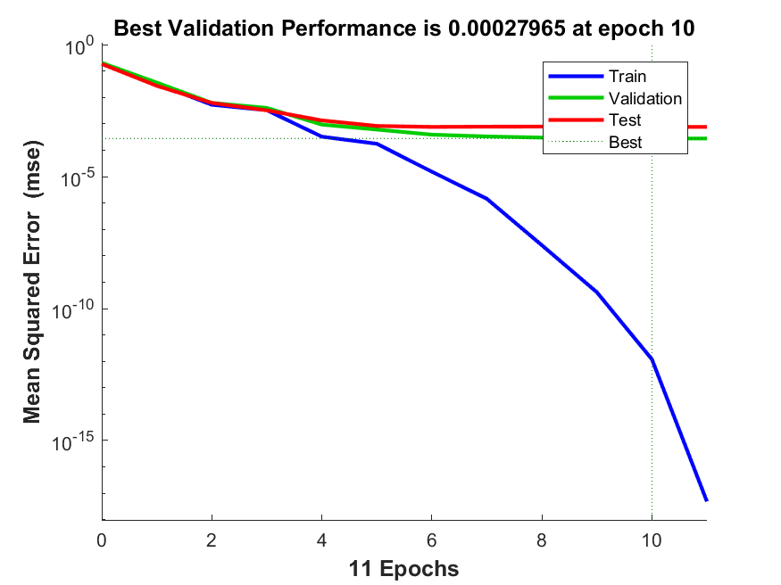

CAN:

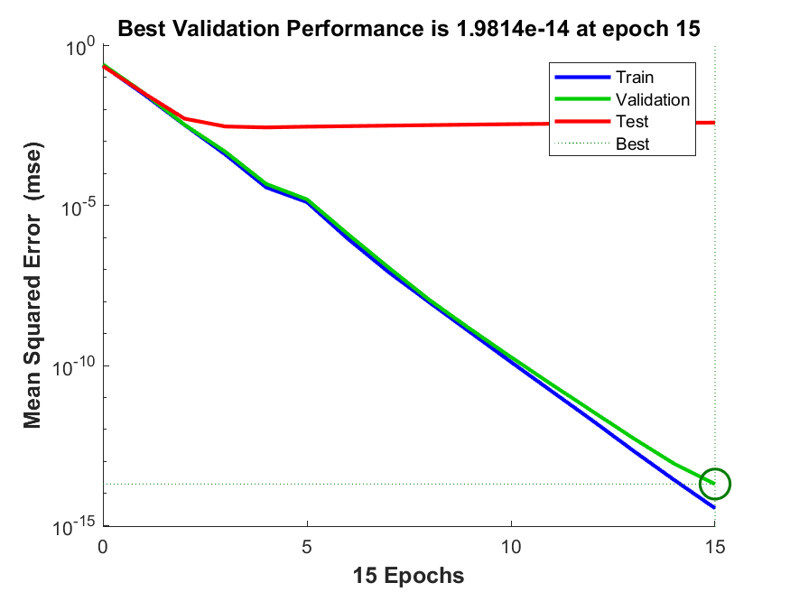

FIND :

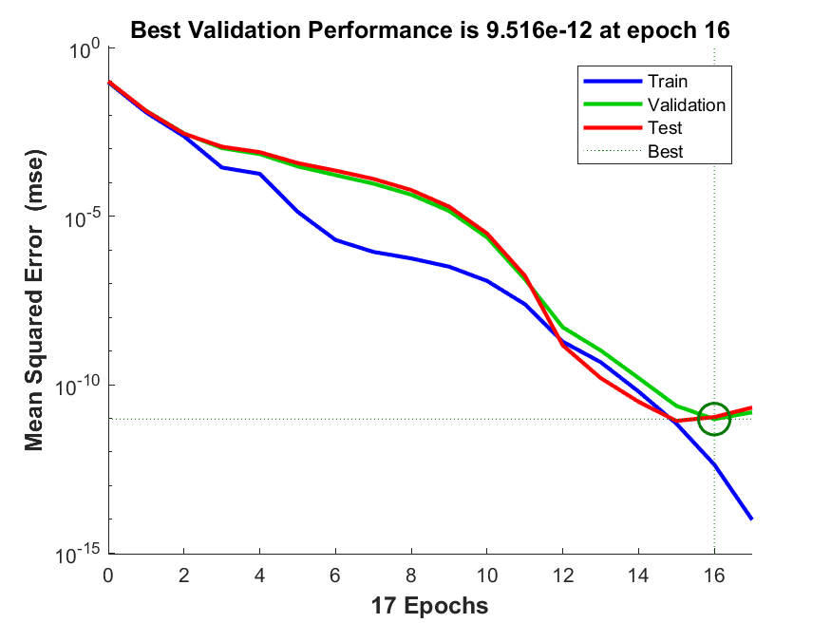

HEARING :

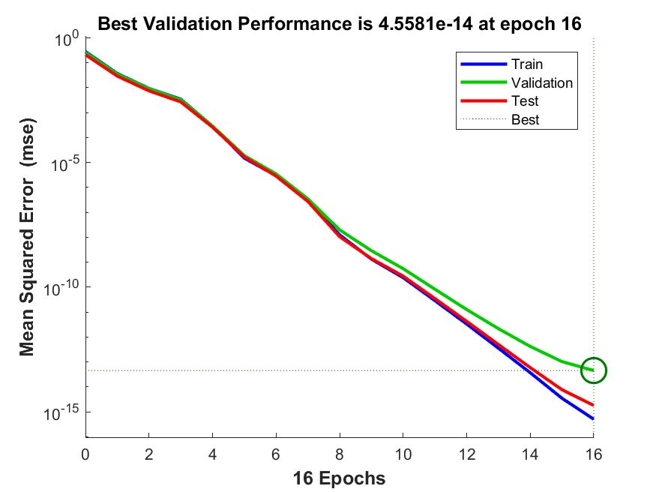

FATHER:

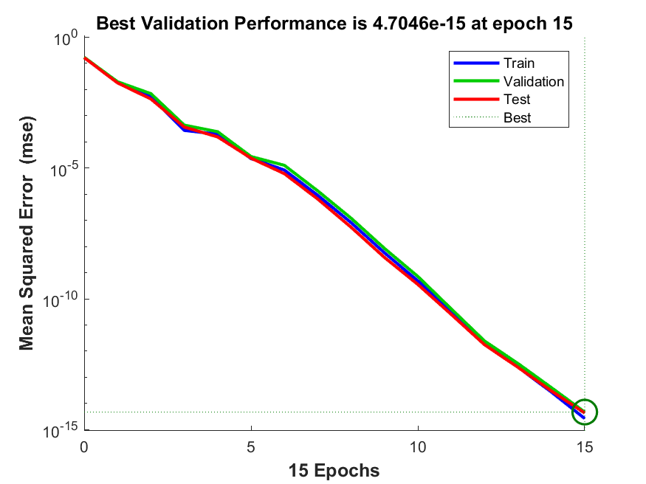

DECIDE :

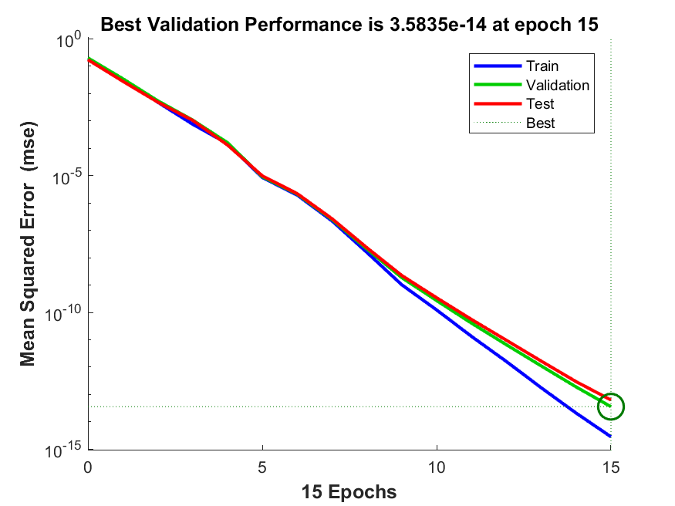

DEAF:

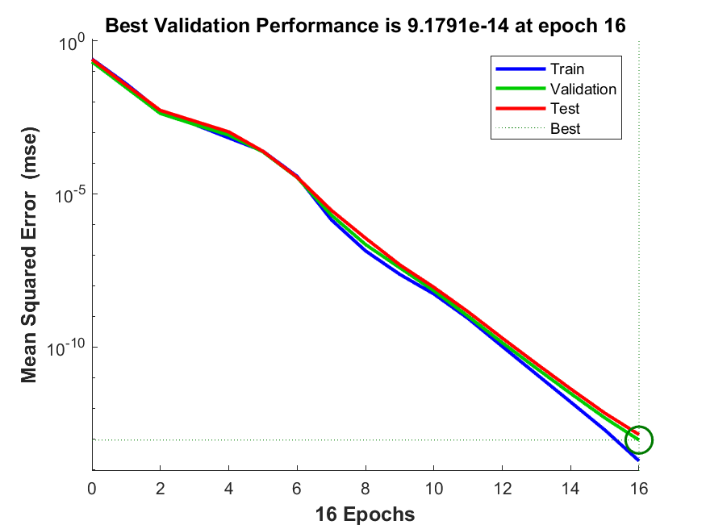

GOOUT:

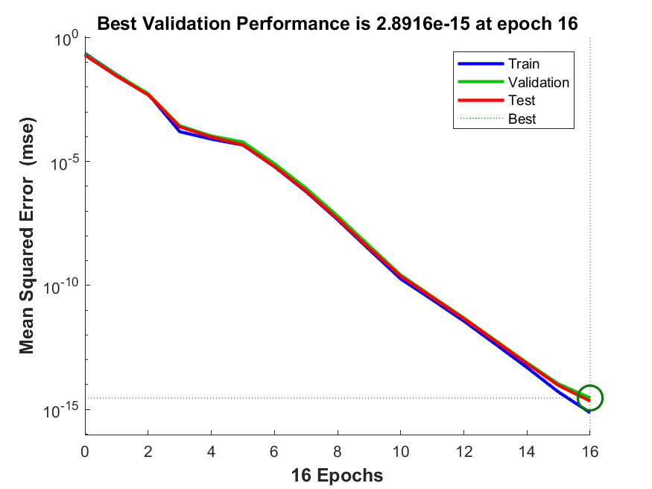

COP:

